SDLC Workspace Engagement Name: | CCMS Application | Business Case ID: | <Business Case ID>
PTS Project Name: | CCMS Application | PTS ID: | <PTS ID>

Document Control

- Document History

Version | Date | Status: <Draft or Final> | Author | Comment / Changes from Prior Version
1.1 | 24.07.2012 |  | Ashrafun Nahar | Initial release.
1.2 | 02.08.2012 |  | Dewan Ahsanullah | Added detail in 4.6 and attached sample file format

- Document Reviewers/Approvers

Name | Position (e.g. Client Manager, Project Manager etc.) | Reviewer (only) | Reviewer and Approver
Dewan Ahsanullah |  | X
Iftekhar Ahmed |  |  | X

Contents

1 Executive Summary 2
2 OVERVIEW 2
2.1 The Business Problem/Need 2
2.2 The Business Goals and Benefits 2
2.3 Critical Success Factors 2
2.4 Assumptions and Restrictions 2
3 Current Processes 2
3.1 Current Processes 2
3.2 Current Limitations 2
4 Description of Requirements 2
4.1 Required Business Processes 2
4.2 Business Scope 2
4.2.1 Business Groups 2
4.2.2 Business Product / Business Transaction Types 2
4.2.3 Primary Business Users 2
4.2.4 External impacts / Other Business groups affected 2
4.3 Specific Business Requirements 2
4.4 Performance Requirements 2
4.4.1 Volumes 2
4.4.2 Potential Growth 2
4.4.3 Performance 2
4.4.4 Exception Handling 2
4.4.5 Usability 2
4.4.6 System Availability 2
4.4.7 Contingency and Disaster Recovery 2
4.4.8 Help and Training 2
4.5 Information Security Requirements 2
4.5.1 General Information Security 2
4.5.2 Authorization and Access Control 2
4.5.3 Audit Logging and Alerts 2
4.5.4 Security Administration 2
4.6 Regulatory, Audit and Data Retention Requirements 2
4.6.1 Regulatory / Audit Requirements 2
4.6.2 Data Retention Requirements 2
5 Delivery and Transition Strategies 2
5.1 User Acceptance Testing Groups 2
5.2 Implementation Considerations 2
5.3 Project Timing Considerations 2
6 Glossary of terms 2
7 Appendices 2

Executive Summary
Citibank, N.A. is providing receivable solutions to its clients through its correspondent banks. Upon receipt of the fund from the respective correspondent banks and the deposit information from the deposit schedule and the slips couriered to us by the coordinator we credit the fund to the clients account as per the arrangement. We have different types of products for clients with guaranteed arrangement too. At present we are processing transactions on the basis of deposit slip deposited at various locations throughout the country. We are using CCMS software which is an EUC locally developed to process these transactions, CCMS has limited capacity to use the deposit slip number which is a big problem right now.

CCMS is developed for Citibank N.A. of Bangladesh. The software is designed to keep tracks of all collection information such as client deposit at different location, generate reminder, maintain billing, DD information and has no Interface between CCMS and their global software to facilitate automatic transactions.

CCMS maintain following products:

- CitiSpeed
- CitiCash
- CitiCheck
- CitiAnywhere collection.

CCMS capture data which is deposited at different location. Deposit amount are collected on Deposit slip. Amount on deposit maintain in the system.

Details of the Product :

Citispeed

Citispeed is the product of Citibank which comprises only check information that is collected by coordinator from different location. Customer Check at different location are collected by coordinator and Deposit these checks to Correspondent bank in which Citibank has an account .These checks are honored through clearing house of that location. After getting these check information with deposit slip input are given to CCMS.

Citicash

Citicash is the product of Citibank which keeps track of deposited cash by citibank’s customer at different locations with correspondent bank. Customer’s cash amount deposited in Correspondent bank at different location which deposit slips is collected by coordinator and they send to CPC for processing and input give to CCMS.

CitiCheck

Citicheck is the product of Citibank which comprises only check information that can be collected by coordinator from different location and send to CPC at Citibank or may be deposit at Citibank counter. After getting these checks information with deposit slip input are given to CCMS. Check deposit at Citibank which is drawn on bank-branches at different location is send to the branches for collection .At the same time system will generate a report of that days processing.

Citi Anywhere check collection

Check deposited which are not covered by clearing house of any location is Citi Anywhere check. These are collection check directly send to drawee bank without any intervention of clearing house.

DD Information

These are return product of Citi Anywhere collection receiving from drawee banks .This DD information is maintained in the system. These will be updated against citianywhere checks. After input system will generate a report for DD update of the day and generate a report which will flow to clearing for fund collection.

OVERVIEW
(Topic Heading – no input required here)

The Business Problem/Need
To support collection operation Bangladesh .it is required a controlled processed environment and system to operate. This is the phase of implementation of CCMS as an application from an EUC.

The Business Goals and Benefits
Implementation of CCMS from EUC to Application will secure the processing platform of receivable transactions and users will get more facility to run BAU including full control over there.

Critical Success Factors
Implement CCMS as an application with required controls and processes for receivables.

Assumptions and Restrictions

Current Processes
(Topic Heading – no input required here)

Current Processes
Attached current processes for receivable products.



Current Limitations

Weakness of opportunity to use the system by users
Strengthen control of processing environment.
System has no ability to cover all the products of receivables that’s why manual activities are huge.

Description of Requirements
(Topic Heading – no input required here)

Required Business Processes
Citispeed

Citispeed is the product of Citibank which comprises only check information that is collected by coordinator from different location. Customer Check at different location are collected by coordinator and Deposit these checks to Correspondent bank in which Citibank has an account .These checks are honored through clearing house of that location. After getting these deposit information’s on deposit slip input are given to CCMS.

There will be two step of data input – first step is deposit schedule entry and 2nd step will be deposit slip detail entry System should have all the fields to input data like deposit slip number, deposit date, correspondent bank name, correspondent branch name, amount, option for marking cash or check etc.

Citicash

Citicash is the product of Citibank which keeps track of deposited cash by citi’s customer at different location. Customer’s cash amount deposited in Correspondent bank at different location which is collected by coordinator. After getting these deposit slips from locations at CPC input will give to the system as citispeed in two different stages.

CitiCheck

Citicheck is the product of Citibank which comprises only check information that is collected by coordinator from different location, under clearing zone. After getting these check information on deposit slip input are given to CCMS. Check deposit at Citibank which is drawn on bank-branches at different location is send to the branches for collection. At the same time system will generate a report for the day of transaction processing.

System pop up for the checks not deposited within 72 hours at the respective locations of input into the system for collection. After input deposit information into the system this window will show the related information’s as availability in the system with update.

CitiAnywhere collection

Check deposited which are not covered by clearing house of any location is Citi Anywhere check. These are collection check directly send to drawee bank without any intervention of clearing house.

Check falls outside of clearing zone for which we input check information’s into
The system first by maker checker and than generate check level advice bank branch wise to send to Drawee bank branches directly from CITI. If returned there should have opportunity to update return status in the system.

DD Information

These are return product of Citi Anywhere collection receiving from drawee banks .This DD information are maintained in the system. These will be updated against citianywhere checks. After input system will generate a report for dd update of the day which will flow to clearing for fund collection.

CITI receiving DD against collection checks from drawee bank branches and update
Into the system are tracking by the reference numbers only generated by CITI .After updating system will generate an advice of the total input for the day .

Citi Anywhere Funding

After receive DD information’s and cleared through the clearing house we update cleared information in the system , system will calculate and generate a file on the basis of maintenances before at account level .there should be a segregation at product level in the system by which we can run and generates a csv file for client credit.

Length of Numbers

We input deposit schedule, collection schedule, and deposit slip level data in the system, currently it is limited for input serial numbers in the specified field, the length of the schedule and slip numbers will be more users friendly.

Reminder

Reminder is sent to different bank at different location mentioning the check information which is not sent by those bank within given times. The time is set by the reversal process considering holiday and customer wise predefined time. Reminder generated for different banks to do either of the following: to sent by demand draft payable at Dhaka city or to return the dishonored check immediately.

Billing

End of month bill is prepared for customers regarding services provided by Citibank. Charges are maintained customer wise. As per agreement with customer, Cash and check charges are defined, also it consider return charges, Courier charges, Bangladesh bank charges ,VAT and other charges. Finally a monthly bill is prepared for each customer considering mentioned criteria.

Search and View Option Enability

View option is necessary for users to check data for future and solve query.

Status change opportunity

Currently there is a bug in the system exist, if anybody view data from data entry screen sometimes status of the check changed which is risky for client credit, sometimes return check entry can be deleted by the users from the CCMS. System should have some protection logic here to protect clients.

Enable option for date of data entry

In data entry screen there is an option for showing date of entry done in the system
Enability of this point is required to find out correct entry date in future.

Authorizing option for data entry

Current system has no facility to authorize data entry after input schedule/slip level, to have better control there will be a checker screen for checking and authorization data input by the makers.

Checker screen will show each and every information’s input by maker and check before authorization, there should be option for sorting to find out the correct data input by specific users, there is also should have an option to reject the data for delete and reinput the data by maker for rejected data. System should have batch level authorization option.

System generate flexecube unloadable file by following maker checker control and stored and throw to flexcube for accounting entry automatically.

System should keep a detail record of data entry user history for each and every data in CCMS.

Audit trail:

System should keep adequate audit trail for any amendment did by the user.

Reports

Additional report requirements with existing list

Citicheck :

Outstanding items reports for Citicheck
Paid reports of Citicheck
Return reports for Citicheck

CitiAnywhere:

Paid report
Return report

Override reports for the day
Override report for Citicash
Override report for Citispeed

Interface with different system :Flexcube ,PPM,EERS

A text file contain daily collection amounts are generated from the software for other system like ( FlexCube) to upload which will credit sundry account and debit corrbank account. This is called booking process .During the file process it checks holiday and prepare data for reversal. Before generating reversal there will be a screen for clearance of checks by maker checker if collection schedule is not updated against checks.

Daily deposit amount pass to IBBS for booking. It credit Bangladesh bank account and debit sundry account. And prepare data for reversal. Every thousand file generation the filename will be initialized and starts from “7000”.
All the clients must maintain their Cash credit day, check credit day, Cash Credit type, speed Credit type. Get max Seq. no from dschedule. Get Batch no for filename. Generate refno starts from “0000000001”. Prepare credit data. Prepare Booking Data. Separate citicheck amount which value date will be less than todate. And Citicash amount of today. And check holiday and make reversal date of each record. Sort all data according to “cash” and “check” wise. Update refno for each record. Now select all data which are check and prepare data for debit. Prepare debit data for cash it like preparing check. After prepare all data generate booking file. Update reference no in master table.

Another process generates a text file to debit sundry account and credit customer account which is called reversal.

After generation these files CCMS should flow both of the files to central software ( Flexcube) automatically without any manual intervention by any user.

File format


PPM: System will also generate file for PPM

EERS: System will generate a file for EERS and also will upload file from EERS.

Work Flow & Data Flow of CCMS:

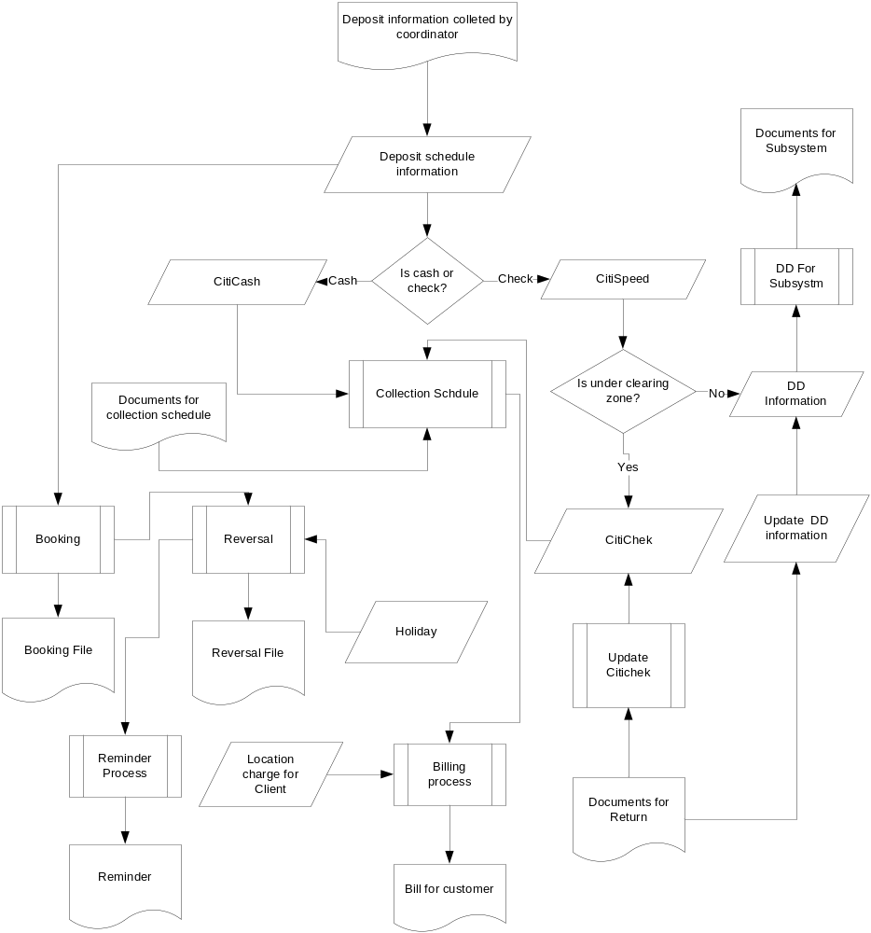

Lookup Input

- Client Information
- Bank Information
- Branch Information
- Correspond Bank Information
- Location Information
- Zone Information
- Reject/Return Information
- Entry Location
- BBK Account Information
- Holiday Information
- Location Charge
- Deposit Schedule Stock

Primary Input

- Deposit Schedule Information
- Cash Detail Information
- Speed Detail Information
- Check Detail Information
- Collection Schedule Information
- DD Detail Information
- Normal Collection Information

Process:
- Flex File Generation
- IBBS Booking
- IBBS Reversal
- Billing
- Reminder

Output (Reports)

- Reminder
- Monthly Bill
- Check Deposit Manifold
- Check For Collection
- Anywhere Funding
- Check Return Report
- Anywhere Reject
- Anywhere Return
- Cash and Speed Summery Report
- Cash Deposit Report
- Speed Deposit Report
- Speed Return Report
- Check Deposit Details Report
- Anywhere Processing
- Anywhere Funding
- Anywhere Outstanding
- Consolidated Speed Report
- Consolidated Bank Deposit
- Check Manifold Reprint
- Check For Collection Reprin

Text Report Generation
1. Speed deposit
2. Speed return
3. Check deposit
4. Cash deposit
5. Speed and citicash summery
6. Anywhere funding
7. Anywhere outstanding

Deposit Schedule Information

Deposit information like client code, client name, location code, location name, bank code, bank name which are selected by user. Moreover these users have to put deposit code, deposit date, total check, total check amount, total cash amount. After clicking on save button these information is saved on database for further process. Sequence diagram of Deposit Schedule is given below:
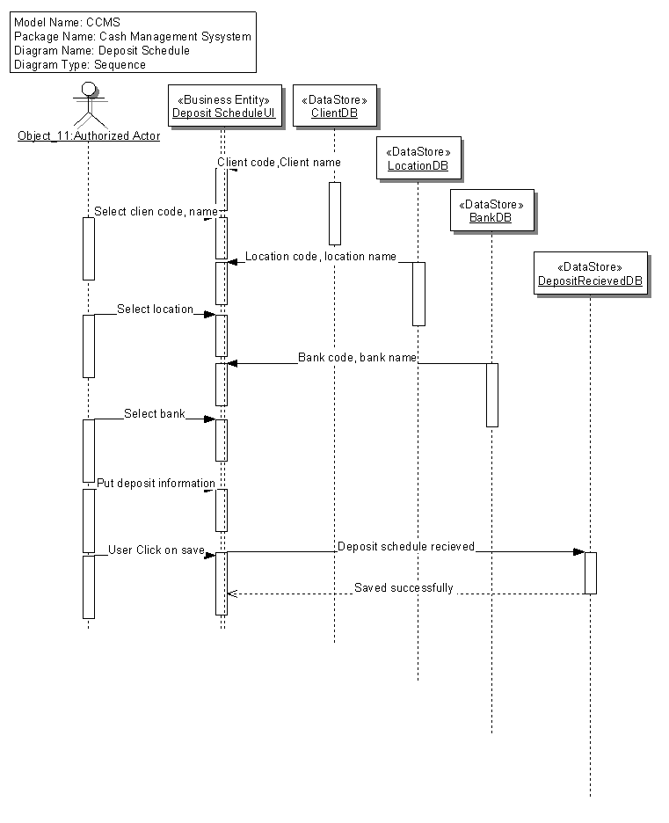

Cash Detail Information
By this form user can update cash detail formation by selecting previously entered data. When he/she put only deposit code then it’s correspond information would be shown like client, location and bank information. Users only have to put slip date, cash reference number and customer reference number. Within clicking on update button this information are updated on database. Sequence diagram of cash detail information is given below:

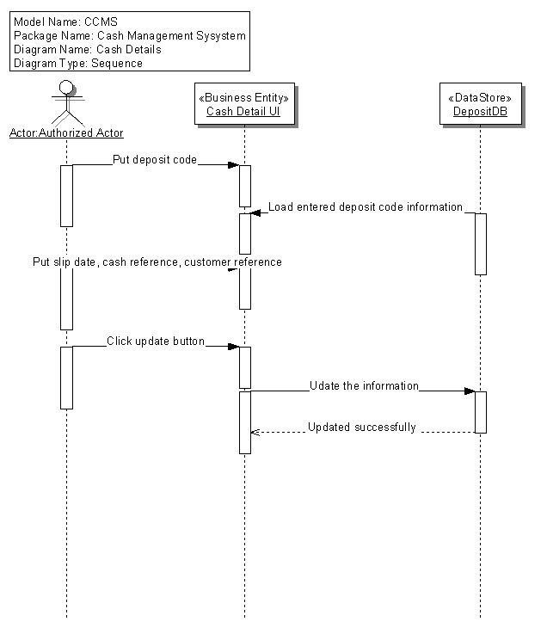

Speed Detail Information
Any authorized employee of Citibank can put deposit code into the system and immediately load the information corresponding deposit code. Then user can put slip no, date, drawer bank, branch, total number of check, total check amount and details information regarding individual check like check number, check amount, check reference number and customer reference number. When he/she click on “Save” button, all information would be saved on database for further processing. Sequence diagram of speed detail Information is given below:

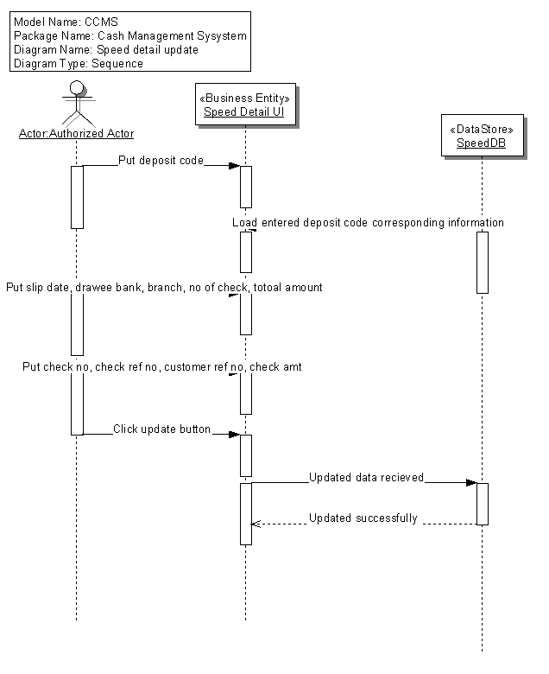
Check Detail Information

User can maintain check information using this form. User should put deposit slip no, client no, slips date, value date, deposit location customer reference number, total checks number and total check amount. User also keep track of each check like check drawer, drawee bank, branch, location, clearing zone, check type, check reference number, check number, check date, reject code, check amount.
By clicking on save button data will be sent to database. The sequence diagram of the check detail information form is given below:

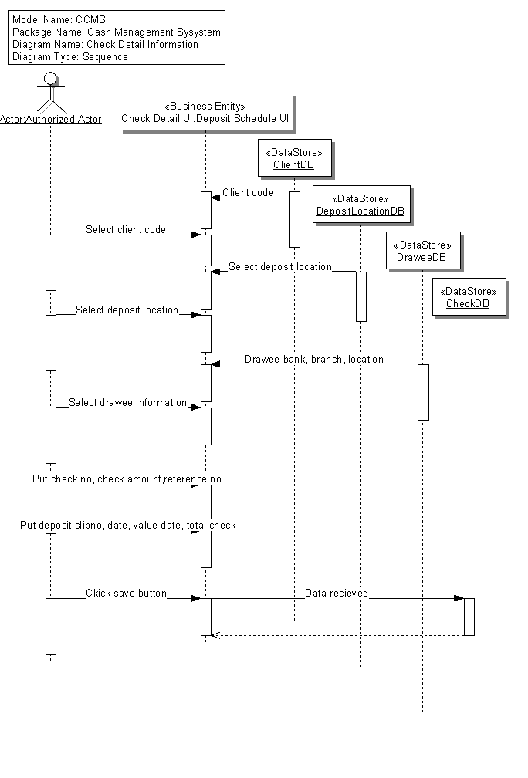

Collection Information
The correspondent will collect the information about check which is already honored or dishonored. With this form user can put information into the system which is very important e.g. collection schedule code, schedule date, location, correspond bank code, deposit schedule code, cash amount, number of check and check amount. The sequence diagram of this form is given below:

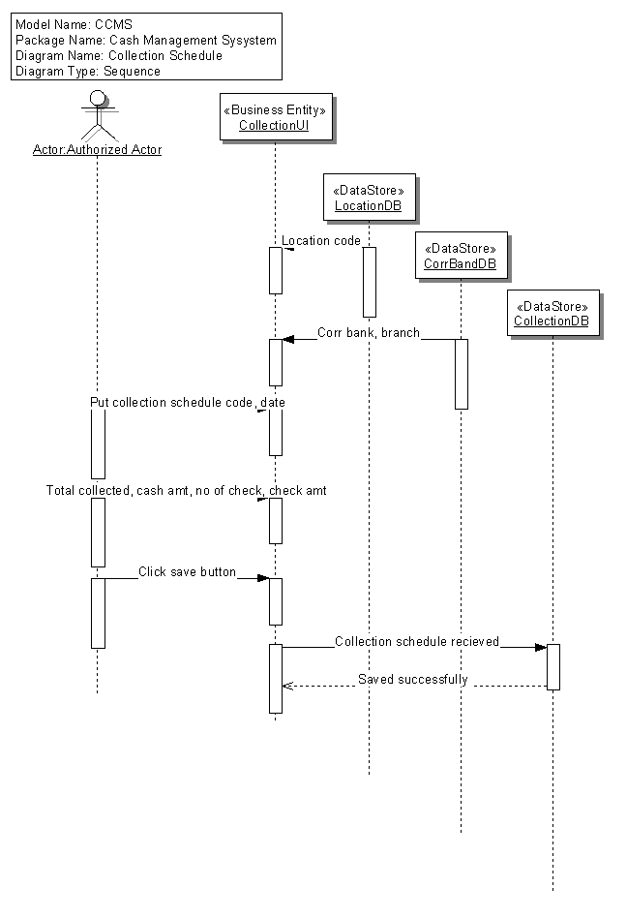

DD Information:
User will also enter other necessary information, i.e. deposit code, entry date, DD number, DD date, bank, branch, location, drawee, DD amount. After clicking on “save” button, this information will be saved. Sequence diagram of DD information is given below:

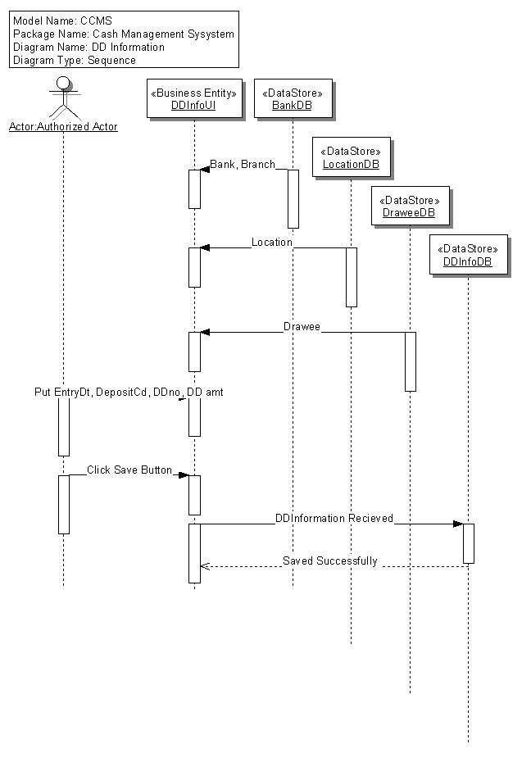

CitiAnywhere Collection Return
Check status is updated if returned from clearing house. While user enters reference number and check number system automatically return information regarding given reference number and check number. After entering return code when user clicks on update button, check status is updated.

Speed collect return:

System has the capacity to update return checks as appropriate.

Business Scope
(Topic Heading – no input required here)

Business Groups
In scope – Cash Mangement Operations ( Collections).

Business Product / Business Transaction Types

In scope – Receivable products of Citibank Bangladesh.

Primary Business Users
Cash Mangement Operations ( Collections). – 7 Users of the unit.

External impacts / Other Business groups affected

NO.

Specific Business Requirements

Key Business Requirement
1 | Point 1 :  Point 2 :
Detailed Description
1.1
1.2
Critical Success Factors
.

Key Business Requirement
2
2.1
2.2
Critical Success Factors

Key Business Requirement
3
Detailed Description
3.1
3.2
Critical Success Factors

Performance Requirements
(Topic Heading – no input required here)

Volumes
Data volume is 2000 daily in average.

Potential Growth

Performance

Exception Handling
System must have capability to handle exception and alert user for rectification

Usability

System Availability

System will be available in working day

Contingency and Disaster Recovery
System will be available in COB site

Help and Training
System must have help menu to understand the functionality of the screen

Information Security Requirements

General Information Security
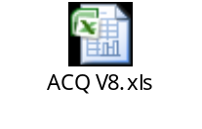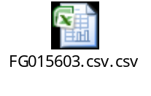

Need to maintain information security standart as per attached excel file

Authorization and Access Control
Separate security module to assign user Access list and restrict unauthorized access.

Audit Logging and Alerts
Audit log is required for
System level such as login, logout, login attempt and
Application level such as ID creation activity log
Transaction level such as maker, checker and date time stamp of the transaction.

Security Administration

Regulatory, Audit and Data Retention Requirements

Regulatory / Audit Requirements

Data Retention Requirements

Delivery and Transition Strategies
(Topic Heading – no input required here)

User Acceptance Testing Groups

Business Group | Region | Requirements to test | Testing New or changed Functionality | Re-testing Current Functionality

Implementation Considerations

Project Timing Considerations

Glossary of terms

Appendices

